Play Dough Recipe

Ingredients Needed:
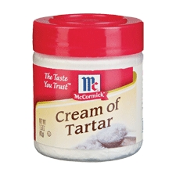
- All-purpose Flour
- Cream of Tartar
- Salt
- Oil
- 1 packet Kool-aid
- Water

Mix Together in a Large Bowl.

1 Cup Flour
2 Tablespoons Cream of Tartar 
1/4 Cup Salt
2 Tablespoons Oil
1 Packet of Kool-aid
1 Cup Boiling Water

Store in Large Ziplock Bag or Air Tight Container. Should last up to 3 months. Enjoy!

